**ASSIGNMENT One – Freshie Veggies**

Student Name: Yashaswini Dummi Kubendrappa, Student ID: 200455939

Technology & Visual Arts, Georgian College – Barrie

21S Mobile Web Applications - 01 (MDEV1005-21S-31166)

Instructor’s Name: Prof. Benjamin

Date: June 7th, 2021

**Farmers Veggies**

Farmers Viggies is a Bootstrap Website. Where people can interact with the local farmers to know more about their vegetables. How they are grown by farmers with love.   
  
In the era of COVID-19, health is in high priority. This website will also help the farmers to sell their vegetables directly to the consumers and build trust and relationships.

In this application I have used Bootstrap Theme to implement this website. Animations are added to the header of the website “Freshie Veggies”.   
  
Alt tags are added to support on blind people for image tags.

Screenshots are uploaded as well in Github. GitHub link - [GitHub Link](https://github.com/200455939-yashu/freshieVegies.github.io)

**WireFrames**

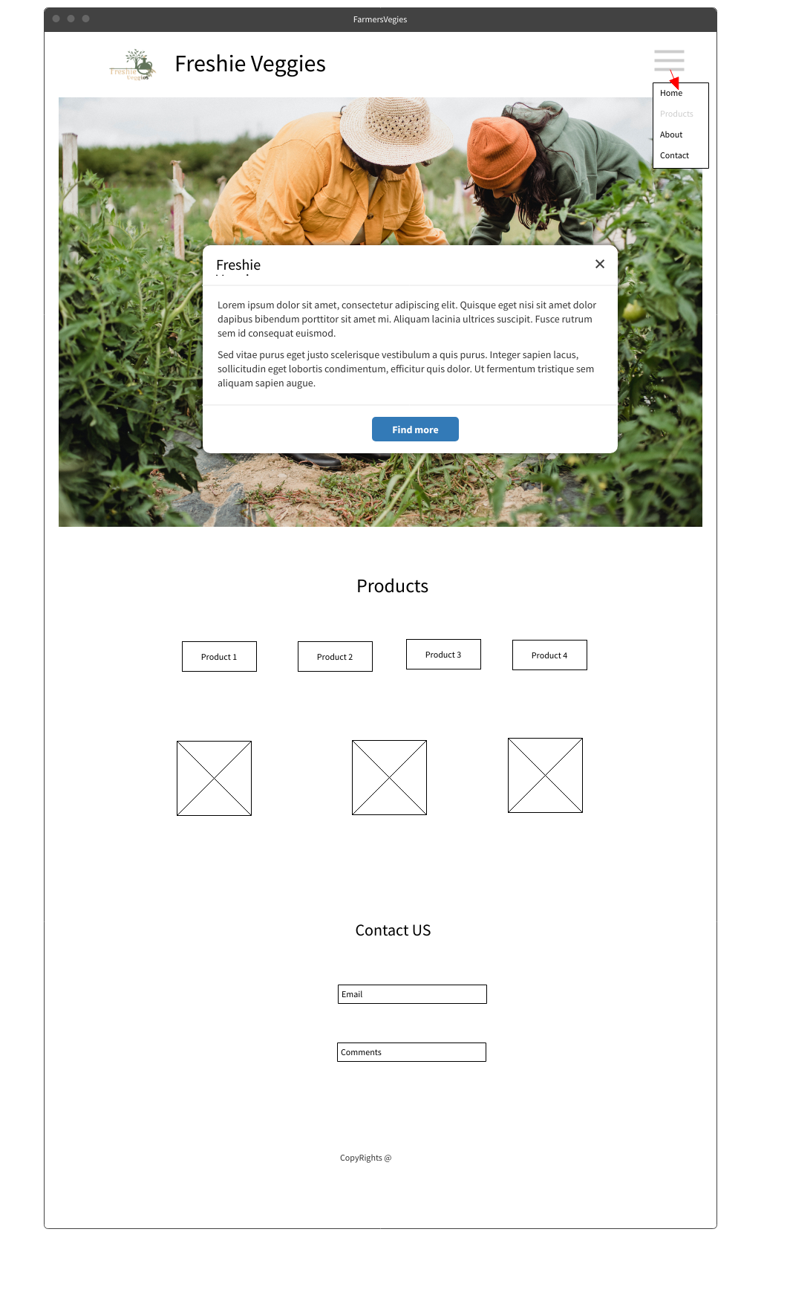

**Testing**

Testing Video is added in the gitHub. A manual testing is conducted to ensure the website is properly functional.

**Privacy Policies**

Privacy Policy Document for this website is as well added in the GitHub. We respect People privacy and follow them accordingly.

[GitHub Link Privacy Policy](https://github.com/200455939-yashu/freshieVegies.github.io/blob/main/ASSIGNMENT%20One%20%E2%80%93%20Privacy%20Policy%20of%20Freshie%20Veggies.pdf)